Skill Evaluation Sheet
Candidate Name: | Gundeboina Naresh Kumar |  | 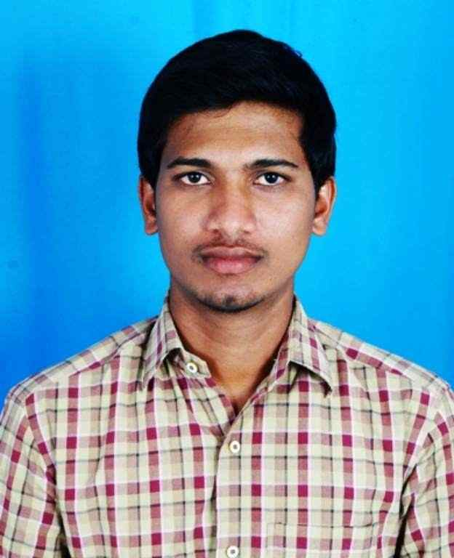
Total Experience: | 7.0 years
Relevant Experience: | 7.0 years
Notice Period: | 30 days
MSP Input |  | Supplier Input
Candidate Skills | Mandatory/ Optional | Name of Projects in which  the skills were used  (Add rows if necessary) | No: of years worked  in each Project | Description of work done  using the skill
Primary Skill 1: | M | ALLEGRO (16,16.6&17.2)  Cadstar (13&16)  Altium (19&20)  Cam350  Hyperlynx  Signal Integrity and Thermal Analysis for PCB Board.  Basic knowledge of XILINX 14.7, Hardware designing |  | Designed a Schematic circuit as per the engineering inputs.  Creation of BOM for the given projects.  Performing Library/part creation, in schematic
Primary Skill 2: | M |  |  | Ability to handle circuit simulation using PSPICE tools  Proficient in handling CADENCE 16.6, designer 19, CADSTAR 16, Expedition and handled CAM350
Primary Skill 3: | M |  |  | Prepare design for PCBs and Bill of Material.  Document all design processes and drawings and all change orders.  Coordinated with PCB designers and planned way to reduce cost in manufacturing process
Secondary Skill 1: | O
Secondary Skill 2: | O
Secondary Skill 3: | O

GUNDEBOINA NARESH KUMAR

Email id: gnsk123@gmail.com
PCB Design Engineer Mobile:+91-9505710102

SUMMARY

Having 5 years of PCB design experience. Proficient in handling PCB designs using EDA tools. Currently, working in Pragati micro instruments as a member technical staff, interested in learning new tool and innovation in Electronics. Ability work as a team and as an individual.

CAREEROBJECTIVE
To climb up the ladder of success in my chosen career with sincerity, interest, and innovation.

TECHNICAL SKILLSET

- ALLEGRO(16,16.6&17.2)
- Cadstar (13&16)
- Altium (19&20)
- Cam350
- Hyperlynx
- Signal Integrity and Thermal Analysis for PCB Board.
- Basic knowledge of XILINX 14.7
- Hardware designing

PROFESSIONAL WORKEXPERIENCE

Currently working at "Pragati Micro Instruments Pvt Ltd." Hyderabad as an "PCB Design Engineer" in the R&D Department From May 2018 to present.

JOB RESPONSIBILITIES

- Designed a Schematic circuit as per the engineering inputs.
- Creation of BOM for the given projects.
- Performing Library/part creation , in schematic

Have good knowledge in reverse Engineering
- Done placement as per the DFM guidelines
- Create Footprint as per IPC standards
- Ability to handle circuit simulation using PSPICE tools
- Proficient in handling CADENCE 16.6,Altium designer 19,CADSTAR 16, Expedition and handled CAM350.
- Handled routing up to 12 layers.
- Length Matching in PCB
- Design layout and ensued that manufacturing requirements.
- Document entire PCB layout and fabrication on system.

Worked at "Elite Circuit Technology Pvt Ltd." as an "PCB Design Engineer" in R&D Department From Dec 2016 to May 2018.

JOB RESPONSIBILITIES

- Maintained symbol libraries for schematic tools and footprint libraries for various PCB design tools.
- Design circuit boards for various systems.
- Update schematics of engineering process.
- Prepare design for PCBs and Bill of Material.
- Document all design processes and drawings and all change orders.
- Coordinated with PCB designers and planned way to reduce cost in manufacturing process.
- Monitor fabrication process and handled all issues regarding same.

KNOWLEDGEOVERVIEW

- Circuit design and Analysis
- EMI Analysis EMC Analysis
- Design of Converters
- Familiar in IPC standards
  - IPC 2221-Generic Standard on PCB design
  - IPC7351- Pad stack Naming convention
  - IPC 7251-Generic requirements of through holes and land pattern standard
  - IPC SM 782-Surface mount design and land pattern standard

- Knowledge in CAN protocol, and PCIe.

ACADEMICPROFILE

- M.tech(VLSI) – Arjun College Of Technology & Sciences, Hyderabad –2019 with 8.09GPA
- B.tech (ECE) – Dhruva Institute Of Engineering And Technology,Yadadri Bhuvanagiri–2015
- Intermediate (M.P.C) – Aurobindo Junior College, Choutuppal –2011
- SSC – ZPHS, Choutuppal –2009

TRAITS
- Flexible to work in different environments, Rapid at learning things

DECLARATION

I do hereby confirm that the information given above is true and to the best of my knowledge

G.NARESH KUMAR

